VISUAL CLASSIFICATION OF VISUALLY IMPAIRED BOWLERS
Important Notes to Assessor:
- The visual assessment must be performed by an Ophthalmologist or a Registered Optometrist and requires the following documentation to be completed in FULL:
- LogMAR TABLES 1 & 2: RIGHT eye unaided & aided visual acuity plus LEFT eye unaided & aided visual acuity
- TABLE 3: CLASSIFICATION FORM

- In all sight tests i.e. visual acuity and visual field, EACH eye must be tested individually.

- Classification of the athlete will be made by the appointed Chief Classifiers after all documentation has been submitted and assessed.

VISUAL ACUITY
- Visual Acuity measurements should be verified using one or more of the following options:
- Grating Acuity(GA) Cards or Basic Vision Test Cards from the Berkeley Rudimentary Vision Test (BRVT) if the athlete is severely visually impaired
- Single Tumbling “E” (STE) CARDS from the Berkeley Rudimentary Vision Test (BRVT)
- LogMAR Tumbling “E” EDTRS ACUITY CHART (LMC) if better visual acuity

- See notes on Page 2 for Guidelines for Acuity Testing

- PAY PARTICULAR ATTENTION TO THE CRITICAL DIVIDING LINES USED IN THE CLASSIFICATION SYSTEM by using repeated measurements all of which must be recorded by placing a cross in the appropriate blocks. A minimum of 5 readings are required per eye except for B1 (if results are inconsistent and show more than 0.2 log MAR difference – allow athlete to rest and repeat with more readings).

- Athlete classification is divided into the following classes as noted by the various shadings:

Limit B1 - unable to recognize single tumbling E 100M at 25cm (LogMAR 2.6 is out)
- The STE is the task used to determine B2/B1 boundary
Limit B2 – unable to recognize single tumbling E 25M at 1m (LogMAR 1.4 is out)
- The STE is the task used to determine the B3/B2 boundary and confirmed with LogMAR ACUITY CHART (big)
Limit B3– unable to recognize the LogMAR 0.9 on the chart = 32M LogMAR chart at 4meters (LogMAR 0.9 is out)
- LogMAR ACUITY CHART is MANDATORY to determine “good VA” border of the B3 range (boundary B3/B4)
Limit B4 – able to recognize LogMAR 0.9 on the chart up to 0.6 LogMar on the chart TOGETHER with OR a field of vision of less than 20 deg in diameter LogMAR 0.5 is out)
- LogMAR ACUITY CHART is MANDATORY to determine VA borders of the B4 range (boundary B4/NE)

VISUAL FIELD
- Visual field shall mean the total visual field and shall be taken as the maximum sum of the fields about the point of fixation along any line through the point of fixation (e.g. temporal plus nasal or upper plus lower), whichever produces the largest result.

- The visual field should be measured with a perimeter that is able to record degrees of field. However, if the fields are reduced to 20 degrees or less the visual field can be assessed with an Amsler Grid Test.

- For Amsler grid testing, the player should be corrected for a working distance of 33cm (add or accommodate +3.00D); the grid is held at 33cm and the player fixates monocularly on the central fixation spot. A target is moved from the edge of the grid towards the fixation spot until it is identified by the player – repeat in all the primary positions or more if needed. Each block is equivalent to one degree when testing at 33cm.

- If any other visual field test (e.g. Goldman Perimeter stimulus III/4e, Humphrey Field Analyzer 10DB or Octopus) is used the results must be able to specify the degree of attainable field and must accompany the application form. Please specify the method(s) used in the space provided on the Classification Form.

- NOTE: FOR INTERNATIONAL EVENTS THE FIELD OF VISION MUST BE MEASURED USING AN AUTOMATED FIELD ANALYZER AND MUST ASSESS THE FULL VISUAL FIELD (80 DEGREES). RESULTS MUST BE SUBMITTED.

GUIDELINES FOR ACUITY TESTING USING BERKLEY RUDIMENTARY VISION TEST (BRVT): STE and big LMC
- Acuity must be measured in the Right eye AND the Left eye – unaided &repeated with best obtainable visual correction
- VA measurements need to be made using different distances and several different Tumbling E sizes. Results must be recorded by placing a cross in the appropriate blocks on the LogMAR TABLES 1 & 2. Results should be consistent - range of variability should NOT be more than 0.2 LogMAR.
- For each eye, at least 5 measurements (except for B1) should be determined with no fixed procedure for letter sequence and distances used.
- If there is significant inconsistency (range bigger than 0.2 LogMAR) then more distances and sizes need to be tested. Allow the athlete to rest and repeat measurements.

It is recommended to start at 1 meter with a 100M Single Tumbling E (STE) card-pair
- If the orientation of the 100M STE can be readily recognized at 1m, increase the working distance until difficult to recognize – record the greatest working distance that the athlete is able to correctly identify the 100M STE.
- Repeat the above procedure with the 63M, 40M and 25M STE cards recording results for each letter size at the appropriate distance.
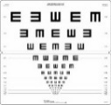
- Whenever the STE measurements are 1.0 LogMAR or better, the big LogMAR CHART (LMC) must be used. Athlete is to identify orientation of the optotypes across each row without isolating – end point is when at least 3(or more) of the 5 optotypes per row are answered correctly:

If the 100 M Single Tumbling (STE) cannot be recognized at 1 meter: Reduce the viewing distance to 25 cm and vary the STE card size – record the smallest STE size at the 25cm working distance that the athlete can correctly identify. Use Grating Charts Acuity Cards or Basic Vision Cards at 25cm if necessary - see table below with testing sequence when severely visually impaired
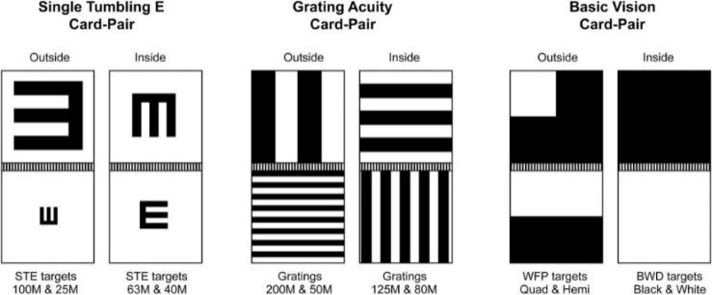

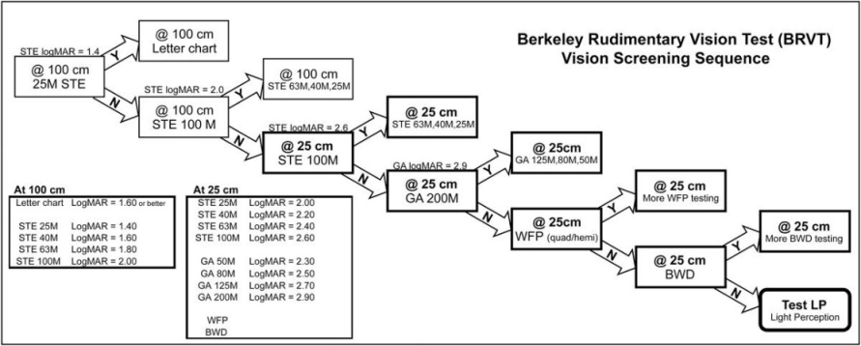

Should any additional explanation be required please contact Hazel Sacharowitz on hazel@lowvision.co.za or What’s App +27 82 3330444
TABLE 1: UNAIDED VA RIGHT EYE – 3 readings minimum OR 5 readings if no refractive error (except B1)
25cm |  | 25cm | Distance | 25cm | 50 cm | 80cm | 1 m | 1,25m | 1,60m | 2,00m | 2,50m | 3,20m | 4,00m | 5,00m | 6,30m
Basic Vision | Gratings | Log MAR | E‘s | Log MAR | Log MAR | Log MAR | Log MAR | Log MAR | Log MAR | Log MAR | Log MAR | Log MAR | Log MAR | Log MAR | Log MAR
NLP | 200M | 2.9 | 100M | 2.6 | 2.3 | 2.1 | 2.0 | 1.9 | 1.8 | 1.7 | 1.6 | 1.5 | 1.4 | 1.3 | 1.2
LP | 125M | 2.7 | 63M | 2.4 | 2.1 | 1.9 | 1.8 | 1.7 | 1.6 | 1.5 | 1.4 | 1.3 | 1.2 | 1.1 | 1.0
BWD | 80 M | 2.5 | 40M | 2.2 | 1.9 | 1.7 | 1.6 | 1.5 | 1.4 | 1.3 | 1.2 | 1.1 | 1.0 | 0.9 | 0.8
WFP | 50 M | 2.3 | 25M | 2.0 | 1.7 | 1.5 | 1.4 | 1.3 | 1.2 | 1.1 | 1.0 | 0.9 | 0.8 | 0.7 | 0.6
 | B1 | B2 | CLASS | B2 | B2 | B2 | B3 | B3 | B3 | B3 | B3 | B4 | B4 | B4 | B4

BEST CORRECTED VA RIGHT EYE– 5 readings MINIMUM (except B1)
25cm |  | 25 cm | Distance | 25 cm | 50 cm | 80 cm | 1 m | 1,25m | 1,60m | 2,00m | 2,50m | 3,20m | 4,00m | 5,00m | 6,30m
Basic Vision | Gratings | Log MAR | E‘s | Log MAR | Log MAR | Log MAR | Log MAR | Log MAR | Log MAR | Log MAR | Log MAR | Log MAR | Log MAR | Log MAR | Log MAR
NLP | 200M | 2.9 | 100M | 2.6 | 2.3 | 2.1 | 2.0 | 1.9 | 1.8 | 1.7 | 1.6 | 1.5 | 1.4 | 1.3 | 1.2
LP | 125M | 2.7 | 63M | 2.4 | 2.1 | 1.9 | 1.8 | 1.7 | 1.6 | 1.5 | 1.4 | 1.3 | 1.2 | 1.1 | 1.0
BWD | 80M | 2.5 | 40M | 2.2 | 1.9 | 1.7 | 1.6 | 1.5 | 1.4 | 1.3 | 1.2 | 1.1 | 1.0 | 0.9 | 0.8
WFP | 50M | 2.3 | 25M | 2.0 | 1.7 | 1.5 | 1.4 | 1.3 | 1.2 | 1.1 | 1.0 | 0.9 | 0.8 | 0.7 | 0.6
 | B1 | B2 | CLASS | B2 | B2 | B2 | B3 | B3 | B3 | B3 | B3 | B4 | B4 | B4 | B4

Visual field <20deg diameter? | Yes  No
OR use Log MAR Chart (LMC) for B3 / B4 border: 5 READINGS MINIMUM

Athlete name: ____________________________________________Date_________

TABLE 2: UNAIDED VA LEFT EYE – 3 readings minimum OR 5 readings if no refractive error (except B1)
25cm |  | 25 cm | Distance | 25 cm | 50 cm | 80 cm | 1 m | 1,25m | 1,60m | 2,00m | 2,50m | 3,20m | 4,00m | 5,00m | 6,30m
Basic Vision | Gratings | Log MAR | E‘s | Log MAR | Log MAR | Log MAR | Log MAR | Log MAR | Log MAR | Log MAR | Log MAR | Log MAR | Log MAR | Log MAR | Log MAR
NLP | 200M | 2.9 | 100M | 2.6 | 2.3 | 2.1 | 2.0 | 1.9 | 1.8 | 1.7 | 1.6 | 1.5 | 1.4 | 1.3 | 1.2
LP | 125M | 2.7 | 63M | 2.4 | 2.1 | 1.9 | 1.8 | 1.7 | 1.6 | 1.5 | 1.4 | 1.3 | 1.2 | 1.1 | 1.0
BWD | 80 M | 2.5 | 40M | 2.2 | 1.9 | 1.7 | 1.6 | 1.5 | 1.4 | 1.3 | 1.2 | 1.1 | 1.0 | 0.9 | 0.8
WFP | 50 M | 2.3 | 25M | 2.0 | 1.7 | 1.5 | 1.4 | 1.3 | 1.2 | 1.1 | 1.0 | 0.9 | 0.8 | 0.7 | 0.6
 | B1 | B2 | CLASS | B2 | B2 | B2 | B3 | B3 | B3 | B3 | B3 | B4 | B4 | B4 | B4

BEST CORRECTED VA LEFT EYE– 5 readings MINIMUM (except B1)
25cm |  | 25 cm | Distance | 25 cm | 50 cm | 80 cm | 1 m | 1,25m | 1,60m | 2,00m | 2,50m | 3,20m | 4,00m | 5,00m | 6,30m
Basic Vision | Gratings | Log MAR | E‘s | Log MAR | Log MAR | Log MAR | Log MAR | Log MAR | Log MAR | Log MAR | Log MAR | Log MAR | Log MAR | Log MAR | Log MAR
NLP | 200M | 2.9 | 100M | 2.6 | 2.3 | 2.1 | 2.0 | 1.9 | 1.8 | 1.7 | 1.6 | 1.5 | 1.4 | 1.3 | 1.2
LP | 125M | 2.7 | 63M | 2.4 | 2.1 | 1.9 | 1.8 | 1.7 | 1.6 | 1.5 | 1.4 | 1.3 | 1.2 | 1.1 | 1.0
BWD | 80 M | 2.5 | 40M | 2.2 | 1.9 | 1.7 | 1.6 | 1.5 | 1.4 | 1.3 | 1.2 | 1.1 | 1.0 | 0.9 | 0.8
WFP | 50 M | 2.3 | 25M | 2.0 | 1.7 | 1.5 | 1.4 | 1.3 | 1.2 | 1.1 | 1.0 | 0.9 | 0.8 | 0.7 | 0.6
 | B1 | B2 | CLASS | B2 | B2 | B2 | B3 | B3 | B3 | B3 | B3 | B4 | B4 | B4 | B4

Visual field <20deg diameter? | Yes  No
OR use Log MAR Chart (LMC) for B3 / B4 border: 5 READINGS MINIMUM

Athlete name: ______________________________________________Date____________

TABLE 3 - CLASSIFICATION FORM FOR LAWN BOWLS
ATHLETE INFORMATION | Date:
Surname: | First name:
Gender: | Date of birth:
Contact Number:
MEDICAL INFORMATION
Visual diagnosis: PLEASE SUBMIT RELEVANT SCANS & PROOF OF DIAGNOSIS IF APPLICABLE

Progressive: Yes / No First diagnosed in year:
Systemic conditions (if relevant):
Ocular / Systemic medication (if relevant) : Please list medications currently being used

Which of the following is used by the athlete in competition: spectacles / contact lenses / none / sunglasses / other:
REFRACTIVE RESULTS
Autorefractor results attached: Yes / No Spectacle Rx / Contact lens Rx / Trial frame as follows:
RIGHT EYE:
LEFT EYE:
LogMAR Visual Acuity Table 1 and Table 2 are completed and attached: Yes / No
VISUAL FIELDS
Test(s) used: Fields attached? Yes / No
RIGHT EYE widest diameter in degrees: Less than 20 deg. diameter? Yes / No
LEFT EYE widest diameter in degrees: Less than 20 deg. diameter? Yes / No
Comments & observations if applicable
MEDICAL PRACTITIONER DETAILS
Name:
Medical Specialty: Ophthalmologist / Optometrist Registration Number:
Mobile No Email:
Signature of Medical Practitioner:

CLASSIFICATION RECOMMENDATION BY NATIONAL CLASSIFIER (Official use ONLY) Circle where applicable
Class: B1 B2 B3 B4 NE
Proposed Class Status: Confirmed / Review date:
Classifier: Email:
Signature: Date:

ATHLETE ASSESSMENT CONSENT FORM

- I agree to undergo the Athlete Assessment process detailed in the IBBA Classification Rules & Procedure and administered by the designated classification team. I understand that this process will require me to participate in sport-like exercises and activities. I understand that there is a risk to injury in participating in exercises and activities and that I am healthy enough to do so. I also agree that if I am injured during the course of this classification process that I will hold IBBA blameless.

- I understand that Athlete Assessment requires me to give my best effort, and that failure to do so may result in me being disqualified from competition. I also understand that discrepancies between performances I demonstrate during Athlete Assessment process and that which I demonstrate during the competition could also lead to my disqualification from competitions.

- I understand that Athlete Assessment is a judgement process and will agree to abide by the judgement of the Classification Panel. If I do not agree with the results of the Classification Panel, I agree to abide by the protest and appeals process as defined by IBBA Classification Rules.

- I agree to be videotaped and photographed during the Athlete Assessment process that may include my activity on and off the field of play during the competition.

- I agree and consent to collating and retaining my personal data in any format, including my Full Name, Year of Birth, Sport Class and Sport Class Status, and agree to consent to my Name, Country and Sport Class and Sport Class Status being published on the website.

Printed name of Athlete: _________________________________________

Signature: ________________________________Date: _______________

